# Create a local git repository and move the entire code base to it

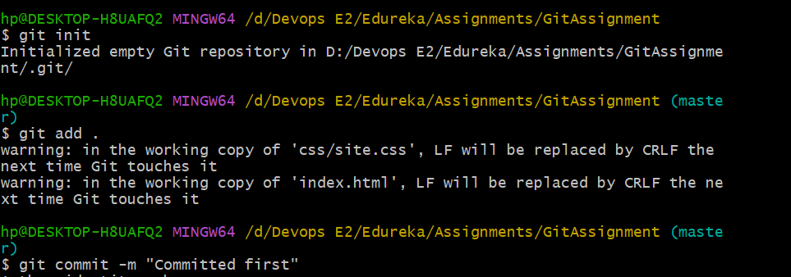

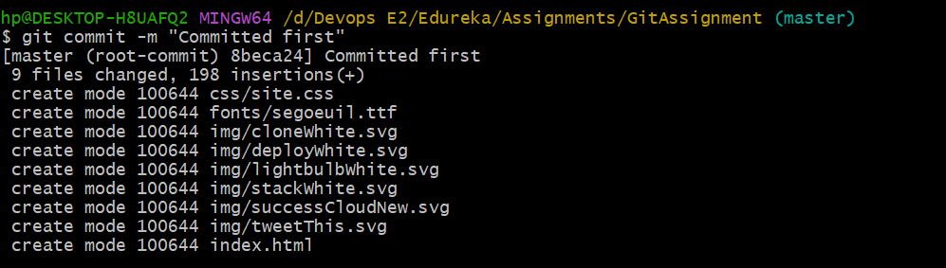

# Create a new branch for a new feature you want to add to the application

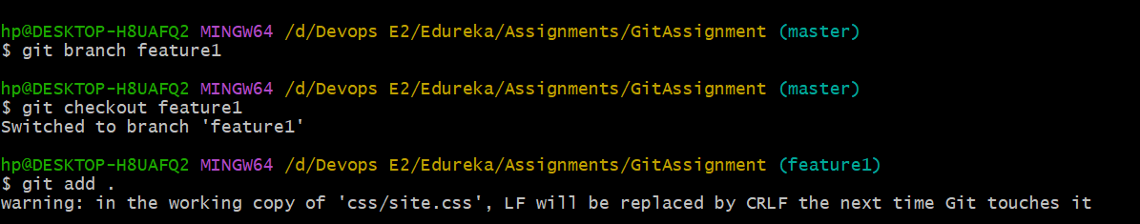

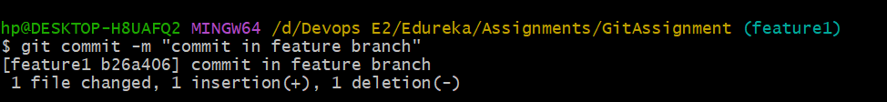

# Merge back the created branch with the master branch

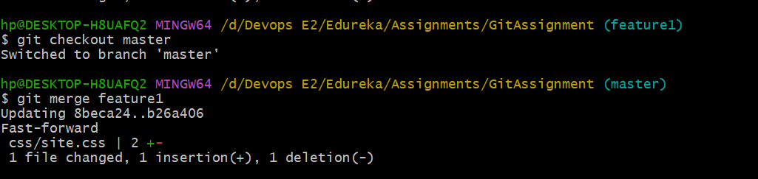

# Create a remote repository

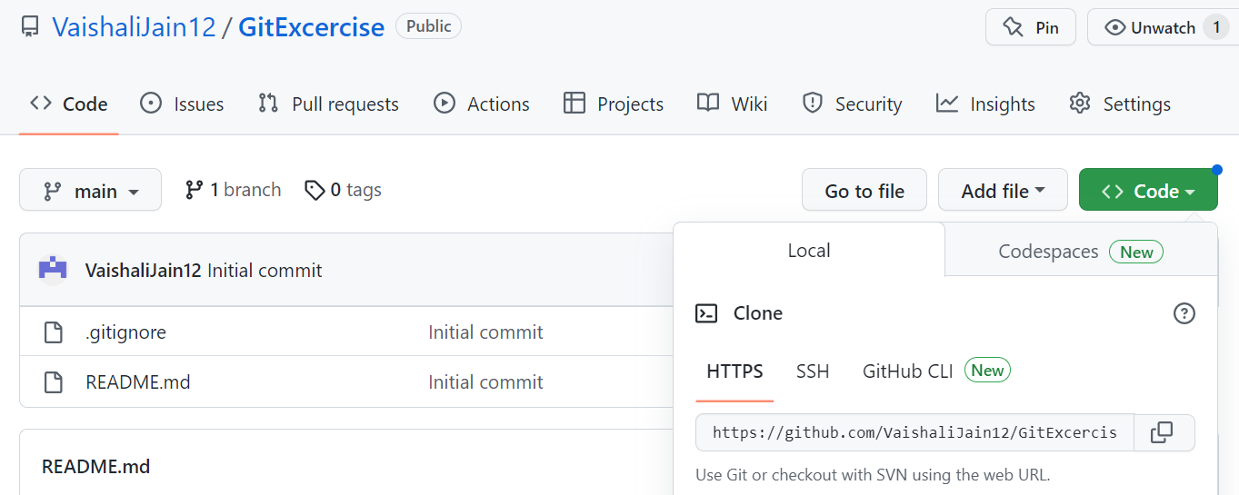

# Push the local repository to company’s remote repository

